Common mode filter (Output power is measured with filter)

|  |  |  |  |  |  |  |
| --- | --- | --- | --- | --- | --- | --- |
| Frequency  (MHz) | Noise power (dBm) | Output power  (no cap) dBm | Output power  (2X100pF) dBm | | Output power  (2X2200pF) dBm | |
| Sym com | real com | Sym com | real com |
| 12 | -18.46 | -54.03 | -56.02 | -65.36 | -78.37 | -78.32 |
| 36 | -18.46 | -51.08 | -59.02 | -63.58 | -85.31 | -85.79 |
| 60 | -19.46 | -49.77 | -61.67 | -63.56 | -88.58 | -93.14 |
| 84 | -20.24 | -48.44 | -63.13 | -63.7 | -92.7 | -97.99 |
| 108 | -21.1 | -47.32 | -64.12 | -64.31 | -96.25 | -112.1 |
| 132 | -22.85 | -47.52 | -66.05 | -66.38 | -103.1 | -97.47 |
| 156 | -23.47 | -46.74 | -66.74 | -67.25 | -113.7 | -91.5 |
| 180 | -26.08 | -48.14 | -69.57 | -70.34 | -105.8 | -89.75 |

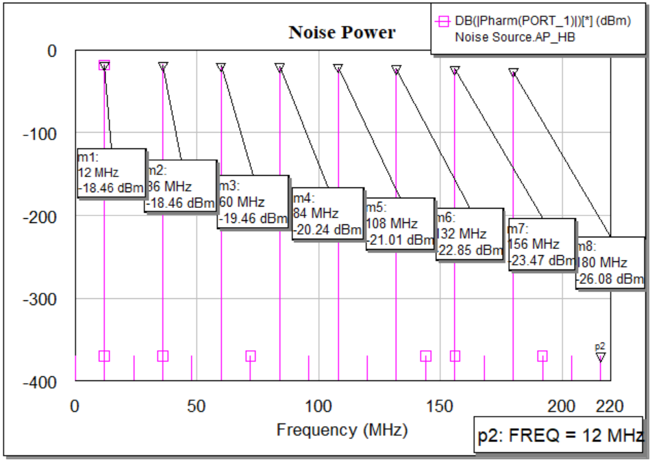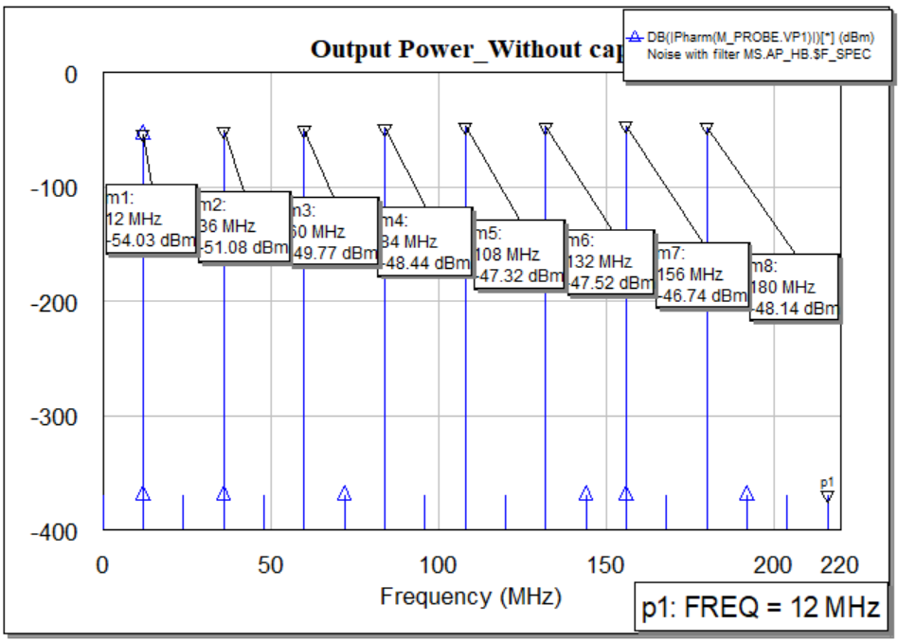

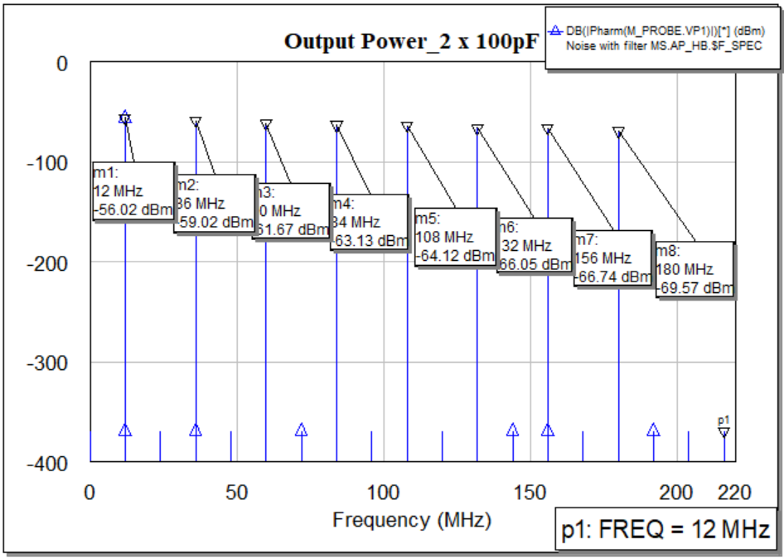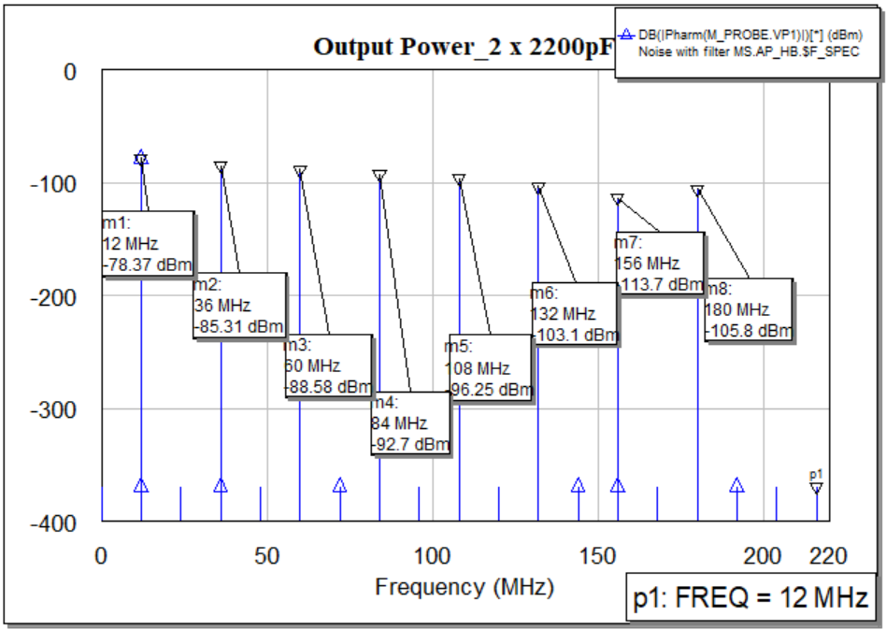

Differential mode filter (Output power is measured with filter)

|  |  |  |  |  |  |  |
| --- | --- | --- | --- | --- | --- | --- |
| Frequency  (MHz) | Noise power (dBm) | Output power  (no cap) dBm | Output power  (1X100nF) dBm | | Output power  (820pF &470pF) dBm | |
| sym com | real com | sym com | real com |
| 12 | -18.46 | -37.53 | -33.59 | -39.71 | -43.07 | -42.61 |
| 36 | -18.46 | -45.77 | -62.45 | -65.51 | -59.07 | -57.65 |
| 60 | -19.46 | -49.01 | -69.25 | -70.41 | -63.94 | -61-94 |
| 84 | -20.24 | -49.82 | -71.29 | -73.2 | -61.14 | -57.63 |
| 108 | -21.1 | -49.33 | -71.37 | -74.71 | -54.47 | -61.0 |
| 132 | -22.85 | -49.01 | -71.36 | -73.88 | -70 | -73.52 |
| 156 | -23.47 | -46.61 | -69.17 | -71.25 | -74.39 | -78.23 |
| 180 | -26.08 | -45.16 | -67.87 | -69.77 | -77.35 | -81.99 |

